IPD CASE PAPER FORM
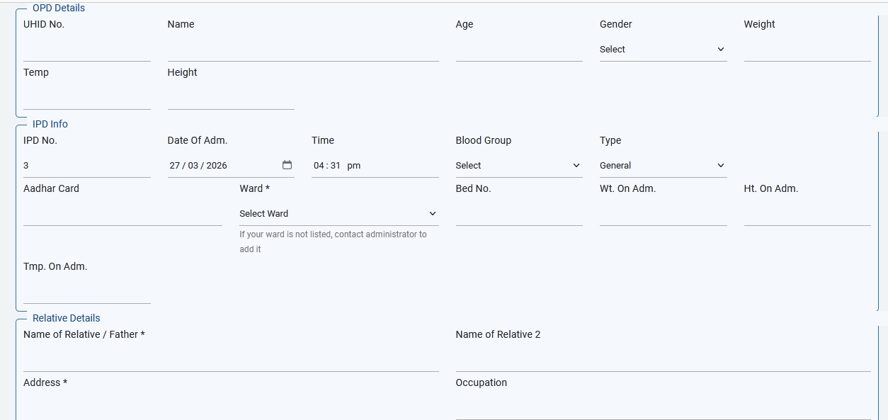
1. DESIGN IT PROPERLY . KHUBACH ODD WATAT AAHE.
2. GIVE OPD SEARCH BY NAME ALSO
3. GIVEN IPD SEARCH ALSO. FORM MODIFICATION IT IS NEEDED.
4. 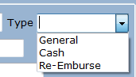
5. 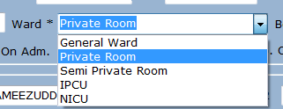
6. 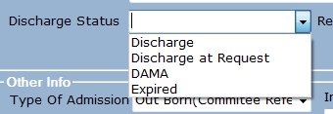
7. 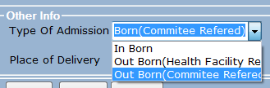
8. 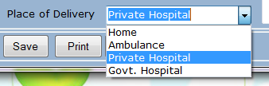
9. 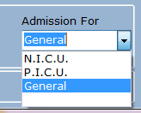

IPD BILL
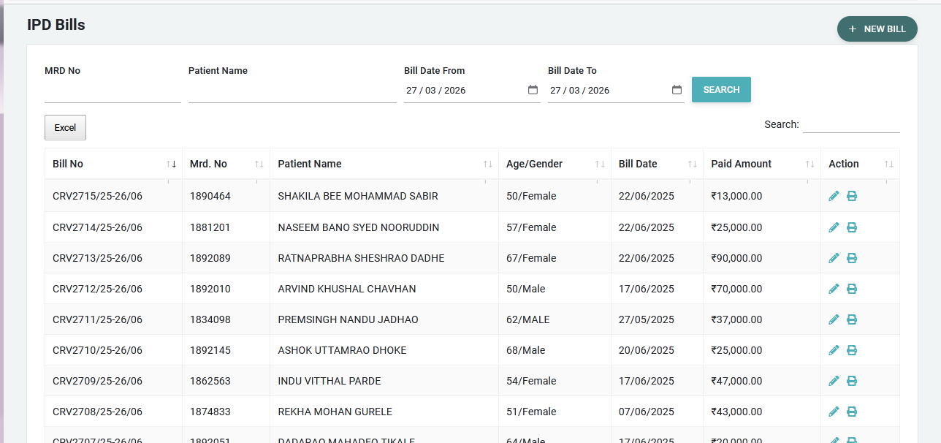
1. YOU ARE SHOWING CASH RECEIPT VOUCHER IN IPD BILL.
2. 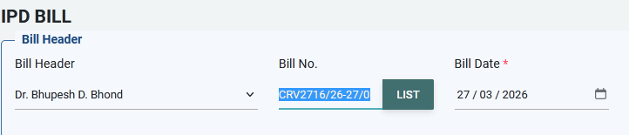
HERE DOCTOR WISE BILL NO SHOULD COME. MADAM ANI SIR HAS SEPARATE SR.NO
3. 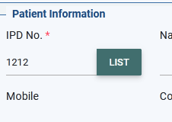
HERE ON CLICKING LIST THE IPD PATIENT SHOULD COME. THEY WILL SELECT PATIENT NAME. OR GIVE DIRECT SEARCH OPTION
IPD RECEIPT
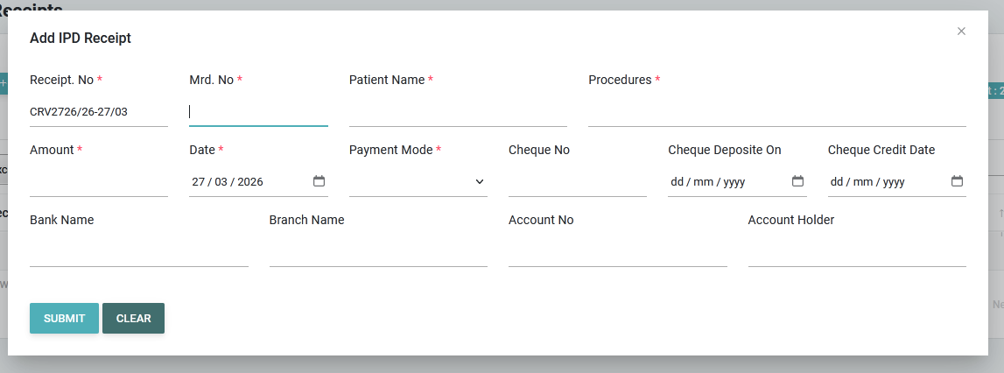
HERE ALSO DOCTOR WISE RECEIPT WITH SEPARATE SR.NO WILL GET GENERATED .
IPD QUEUE
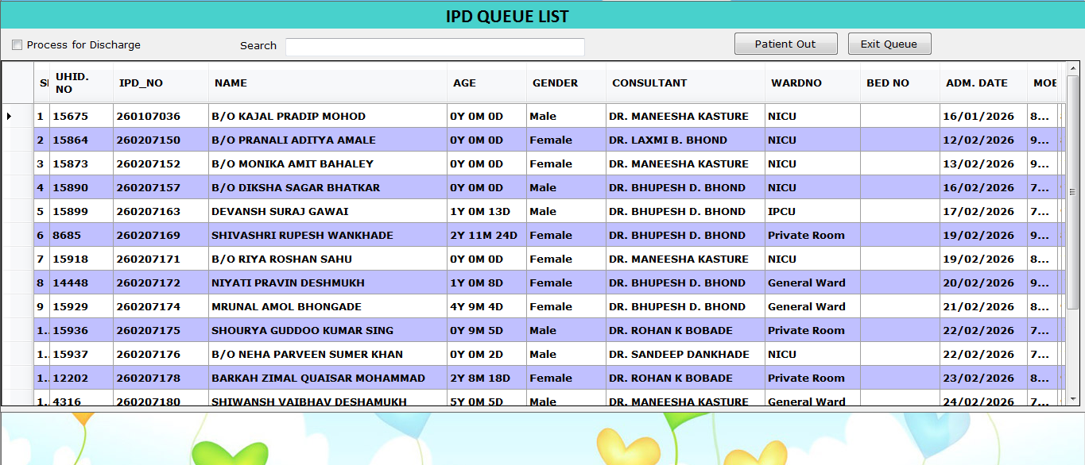
THIS FOR IPD QUEUE SEPARATLY. LIKE OPD QUEUE. THERE PATIENT WILL REMAIN UNLESS THEY HAVE GIVEN THE DISCHARGE.

