Parijat Hospital
New Patient
- Remove the print sticker option after saving the record
- Give search (auto search) in City
- If the patient is for vaccination (check box click) give pink color in queue

queue management
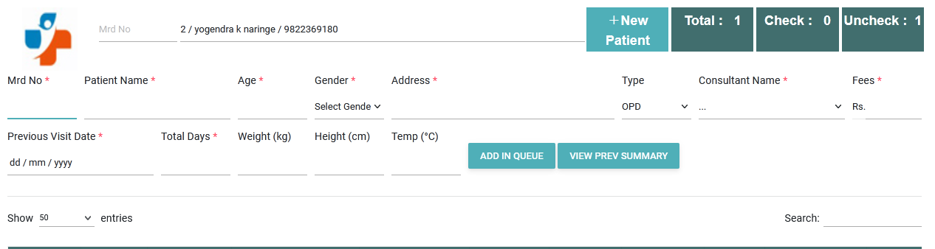
1. search icon not visible even search not working if put directly mrd no
2. if directly search by name its shows but could not show details of patient
Consultant page :
1. Like advice Investigation text box with selection option mission
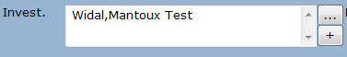
advice also has selection option
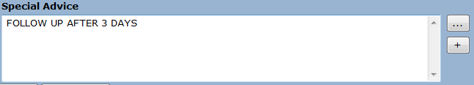
3. over all form design not proper
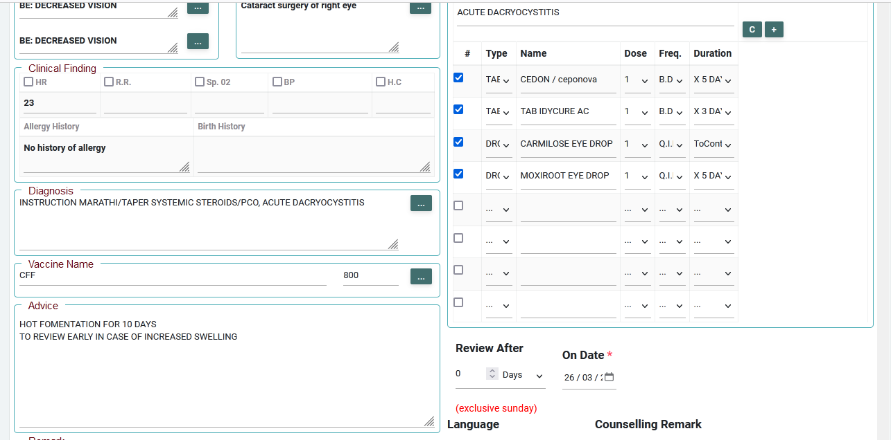
4. There is a check bok for normal finding (NF) . if we click on that the default reading come if RS, CVS,THROAT, CNS, P/A
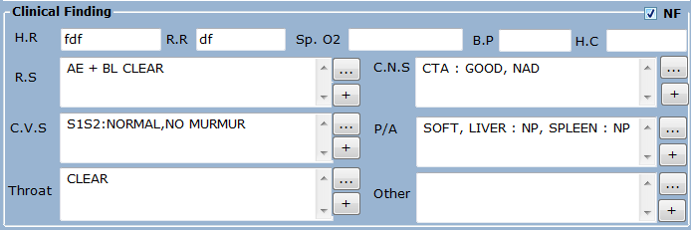
5. if consultant add anything in vaccination it goes to vaccine queue. you have created investigation queue. rename it as vaccine queue and make it on vaccination text.
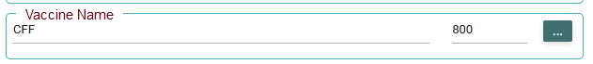
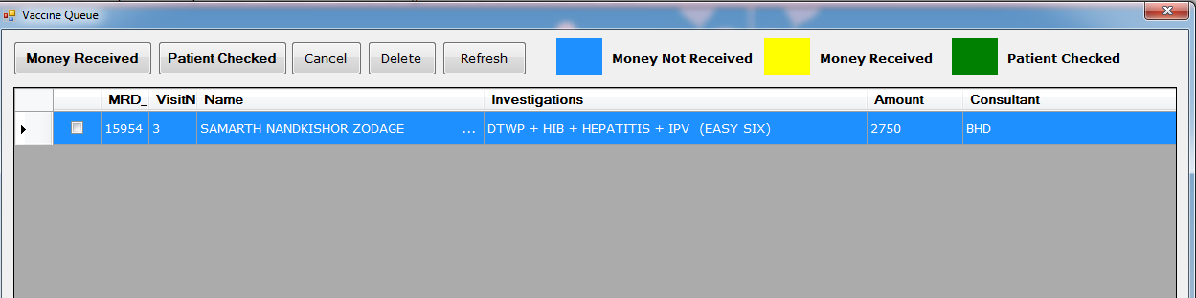
6. remove past ocular history and keep the complaint box width big
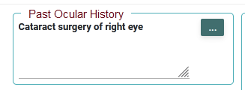
7.
Remove check boxes . directlt keep text box, move allergy history and birth history above hr , rr,sp02,bp,hc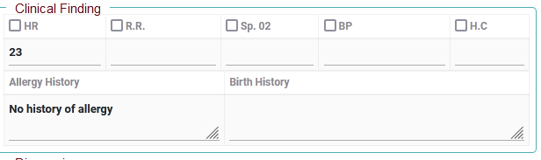
Menu :
keep sub menu like this
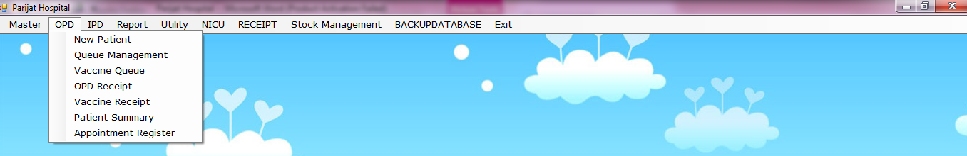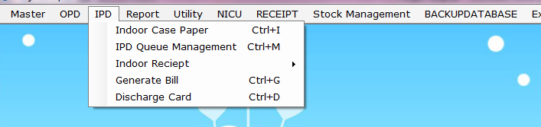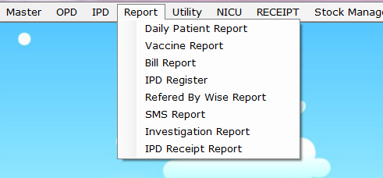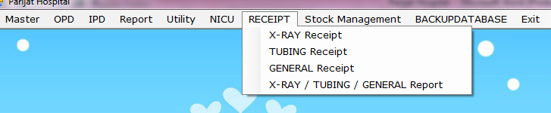

Implement Parijat Hospital UI Improvements:

1. Remove print sticker after patient save
2. Add city auto search
3. Add vaccination checkbox
4. Highlight vaccination queue pink
5. Fix queue search
6. Consultant page redesign
7. Add normal finding autofill
8. Rename investigation queue to vaccine queue
9. Remove past ocular history
10. Reorder form layout
11. Convert checkboxes to text fields
12. Add advice dropdown
13. Add investigation autocomplete
14. Improve UI responsive layout
15. Add queue priority system

